**Workforce Solutions**

**Help for Individuals Affected by Hurricane Harvey**

**How do I help a person who has been affected by Hurricane Harvey?**

We help each customer as we always do: we listen to what the customer tells us she wants or needs and we decide how we can use our resources and service to help her.  
  
We can help a customer who has lost a job or is out of work because of the hurricane:

* Apply for disaster unemployment assistance
* Go to a FEMA Disaster Recovery Center to apply for disaster assistance
* Look for work or go to work
* Apply for Workforce Solutions temporary jobs in clean-up and repair
* Get training to go to work

**How do I help someone apply for disaster unemployment assistance (DUA)?**

1. Help the customer access and if necessary complete the application online at <http://www.twc.state.tx.us/jobseekers/unemployment-benefits-services>.

Remember that customers who have recently applied for or received unemployment compensation may have a TWC account. TWC may require the customer to reset a PIN, User ID or Password to proceed with the DUA application.

To reset a PIN:

Help the customer call 800-558-8321 and select option 4 to reset/create a new PIN by providing personal information from your claim such as:

* Birth date
* Texas driver’s license or ID number
* Telephone number
* Amount of your last benefit statement
* Part of your bank/credit union account number

To reset a User ID or Password:  
  
From the TWC online home page at <http://www.twc.state.tx.us> help the customer:

* Select Disaster-Related Unemployment Benefits under Quick Links
* From there, select “Submit An Application for Unemployment Benefits” under the header “Apply for Benefits”
* Select “Forgot Password?” or “Forgot User ID?” listed under the Quick Links section of the Unemployment Benefit Services page
* A customer must answer security questions he or she set up when he or she created her User ID

1. Help or advise the customer to call the TWC Tele-Centers at 800-939-6631.

* Tele-Centers are open Monday through Friday, 7:30 a.m. to 6:30 p.m.
* It is best to call very early or late
* There will be long waits on the telephone – you can advise a customer to apply online first.

**How do I help someone apply for FEMA or Small Business Administration disaster assistance or go to a FEMA Disaster Recovery Center?**

1. You can help a customer apply online for FEMA disaster assistance by directing the customer to [www.disasterassistance.gov](http://www.disasterassistance.gov)
2. Phone FEMA at 800-621-3362 (voice, 711/VRS-Video Relay Service) (TTY: 800-462-7585). Multilingual operators are available (press 2 for Spanish)
3. Use the FEMA app, available for Apple and Android mobile devices. To download visit: [fema.gov/mobile-app](https://www.fema.gov/mobile-app)
4. Direct the customer to the nearest FEMA Disaster Recovery Center. There are currently nine DRCs in our region, in Harris, Fort Bend, Wharton, Colorado, and Montgomery counties. Use the FEMA DRC locator to help the customer find the nearest DRC, the hours of operation, and service available at that site: <https://www.fema.gov/disaster-recovery-centers>
5. The U.S. Small Business Administration offers loans to small businesses and homeowners for repair. Direct a customer to the nearest DRC with SBA service for help in applying.

**How do I help a customer apply for Disaster SNAP benefits?**

Customers must apply in person at a designated D-SNAP location in their county of residence. They will not be able to apply online. D-SNAP applications will be accepted for a limited amount of time in each county.

To apply, customers will need to show proof of identity - Examples include a driver’s license or other government-issued ID

For more updated information please check the Texas Health and Human Services information about Disaster SNAP: <https://hhs.texas.gov/services/financial/disaster-assistance/disaster-snap>

**How do I help a customer look for work or go to work?**

As we do every day:

* Help the customer enter or update an application in WorkInTexas and search for jobs that match his or her education, skills and experience.
* Find or search jobs in WorkInTexas to match to the customer
* Make referrals
* Let customers know of any Workforce Solutions hiring events that he or she might be interested in

**How do I help a customer apply for Workforce Solutions temporary jobs in clean-up and repair?**

1. Workforce Solutions will be developing temporary jobs with area local governments over the next several weeks. These jobs will involve clean up and repair, renovation and rebuild of public structures, facilities and lands. Jobs will be posted in WorkInTexas, and Workforce Solutions staff will be notified as jobs become available.
2. The career office will determine if a customer is eligible for a temporary job.
3. Eligible customers will be screened, selected, hired and placed at a worksite for temporary jobs by a staffing firm authorized by Workforce Solutions.
4. Offer financial aid to customers eligible for temporary jobs if they want or need that assistance. This includes financial aid for short-term training.
5. Career offices will identify, determine eligible, track and follow-up customers who are eligible for temporary jobs.

**How do I help customers get training to go to work?**

1. Customers who are eligible for temporary jobs are also eligible for scholarships for specific training related to hurricane recovery.
2. We will provide additional information in the near future on how to access these special short-term training opportunities.
3. As always, customers may apply for scholarships through our regular process.

**Temporary Jobs/Financial Aid Eligibility**

1. Career Office staff will be responsible for determining eligibility for Harvey recovery temporary jobs.
2. Customer must complete the Financial Aid Application (found at <http://www.wrksolutions.com/for-individuals/financial-aid/how-to-apply-for-financial-aid>)
3. Eligibility requirements include 1, 2, and any one of 3, 4, 5, or 6
4. Eligible to work in US, and
5. Registered for Selective Service when applicable, and
6. Individuals who are temporarily or permanently dislocated from work because of the covered disaster, or

Accept self-attestation. Staff must verify receipt of Unemployment Assistance benefits within 30 days.

1. Dislocated Worker - Individuals who qualify as dislocated workers under WIOA, or
2. Laid off – all three elements below apply:
3. Terminated or laid off,
4. eligible for or exhausted UI and
5. unlikely to return to industry or occupation; or
6. Lost job from permanent closure or substantial layoff of a plant, facility or enterprise; or
7. Was self-employed and now unemployed because of economic conditions or natural disaster; or
8. Displaced Homemaker; or
9. Spouse of a member of Armed Forces who lost employment due to permanent change in duty station or is unemployed, underemployed and has difficulty finding or upgrading employment.

Reference [Validating and Entering Qualifications for Financial Aid](http://www.wrksolutions.com/Documents/Staff/fin-aid-app-inst/helpful-desk-aids/Validating-Entering-Qualifications-for-Financial-Aid.pdf) for documentation sources.

1. Individuals who are long-term unemployed – (an individual who **has been unemployed for at least 10 weeks.** (This definition only applies to the Hurricane Harvey NDWG funding.)
2. Self-employed individuals who became unemployed or significantly underemployed because of the emergency or disaster.

Accept self-attestation.

**Tracking in WorkInTexas.com and in TWIST**

**WorkInTexas.com**

Hurricane Harvey Enhancements for Job Seekers

There is a new question on the Job Seeker’s **Personal Information** page, *“Have you been impacted by Hurricane Harvey?”* If the Job Seeker answers Yes, a new Hurricane Harvey cid:image003.gif@01D32311.17B59A30 icon will be displayed on the Job Seeker’s pages where other icons would be displayed. If they answer No, the icon will not be displayed. **Note:**The **Group Job Seeker Search** functionality to find and identify Job Seekers impacted by Hurricane Harvey is not currently available, but will be included in the next release.

When searching for Job Postings, the **Job Posting Browse – Results** page will display a Hurricane Harvey cid:image003.gif@01D32311.17B59A30 icon for Job Postings that have been identified as Harvey-related.

Hurricane Harvey Enhancements for Employers

The WorkInTexas.com home page now includes the following note and link: *“Employers interested in posting multiple jobs please click* [*hurricaneharvey.jobs registration*](http://us.jobs/indexingrequest.asp?phase=3&state=HH) *in partnership with US.jobs.”*

Employers who enter their Job Postings through WorkInTexas.com may identify a Job Posting as related to Hurricane Harvey clean-up by answering a new question *“Is this job related to Hurricane Harvey Clean-up/Restoration?”* on the **Job Posting – General Details** page. **Note:** Employers who submit their Job Postings via XML or indexing do not have the ability to answer the new question, so they’re not able to identify their Job Postings as Harvey-related.

When searching for Job Seeker matches for their Job Posting, the **Job Posting – Match Results** page will display a Hurricane Harvey cid:image003.gif@01D32311.17B59A30 icon next to Job Seekers who identified themselves as being impacted by Hurricane Harvey.

**Workforce Solutions is entering Harvey2017 in the “Employer Posting No.” field.**

**Tracking in TWIST**

The fund code for the National Dislocated Worker Grant (NDWG) is:

207 – Hurricane Harvey NDWG.

There is a sub fund to track Hurricane Harvey evacuees:

71 – Hurricane Harvey Evacuee

Office 5 – 2084 – TX32 – HARVEY RELIEF

Child care is an allowable supportive service under the disaster grant.

Staff should use service 43 – Subsidized Work – Other Funds to track customers who will be participating in disaster relief employment using the fund code 207 – Hurricane Harvey NDWG.

The Hurricane Harvey sub fund has been made available to the following fund codes:

1 - OneStop

10 - WIOA Adult

11 - WIOA Adult Statewide

20 - WIOA Dislocated Worker

21 - WIOA Dislocated Worker Statewide

30 - WIOA Youth

31 - WIOA Youth Statewide

87 - SNAP E&T ABAWD

88 - SNAP E&T General Population

89 - Choices

90 - TANF Applicant

91 - Choices Plus

100 - Rapid Response Additional Assistance

101 - Rapid Response

120 - Employment Services

121 - Trade Adjustment Act

136 - TAA/Other

179 - NCP Choices

The Hurricane Harvey codes have been added to the following Workforce Reports:

1 – Active List

6 – Late Data Entry

19 – Exit List

35 – Inactive List

37 – Management Summary

76 – Case Load

134 – Customers Served Report

**Child Care – National Dislocated Worker Funds**

* Establishing Child Care in TWIST for NDWG Customers
* When setting up Child Care services under the Hurricane Harvey NDWG funding (Special Projects: 8 NDWTX32), staff should select the Extended Year Exemption when creating the Child Care program detail. This will allow TWIST to bypass checks that require income eligibility and participation hours. Eligibility for NDWG is based on participation in NDWG-funded employment or training. *Documentation of income and minimum participation hours are not required.*

Intake-Common

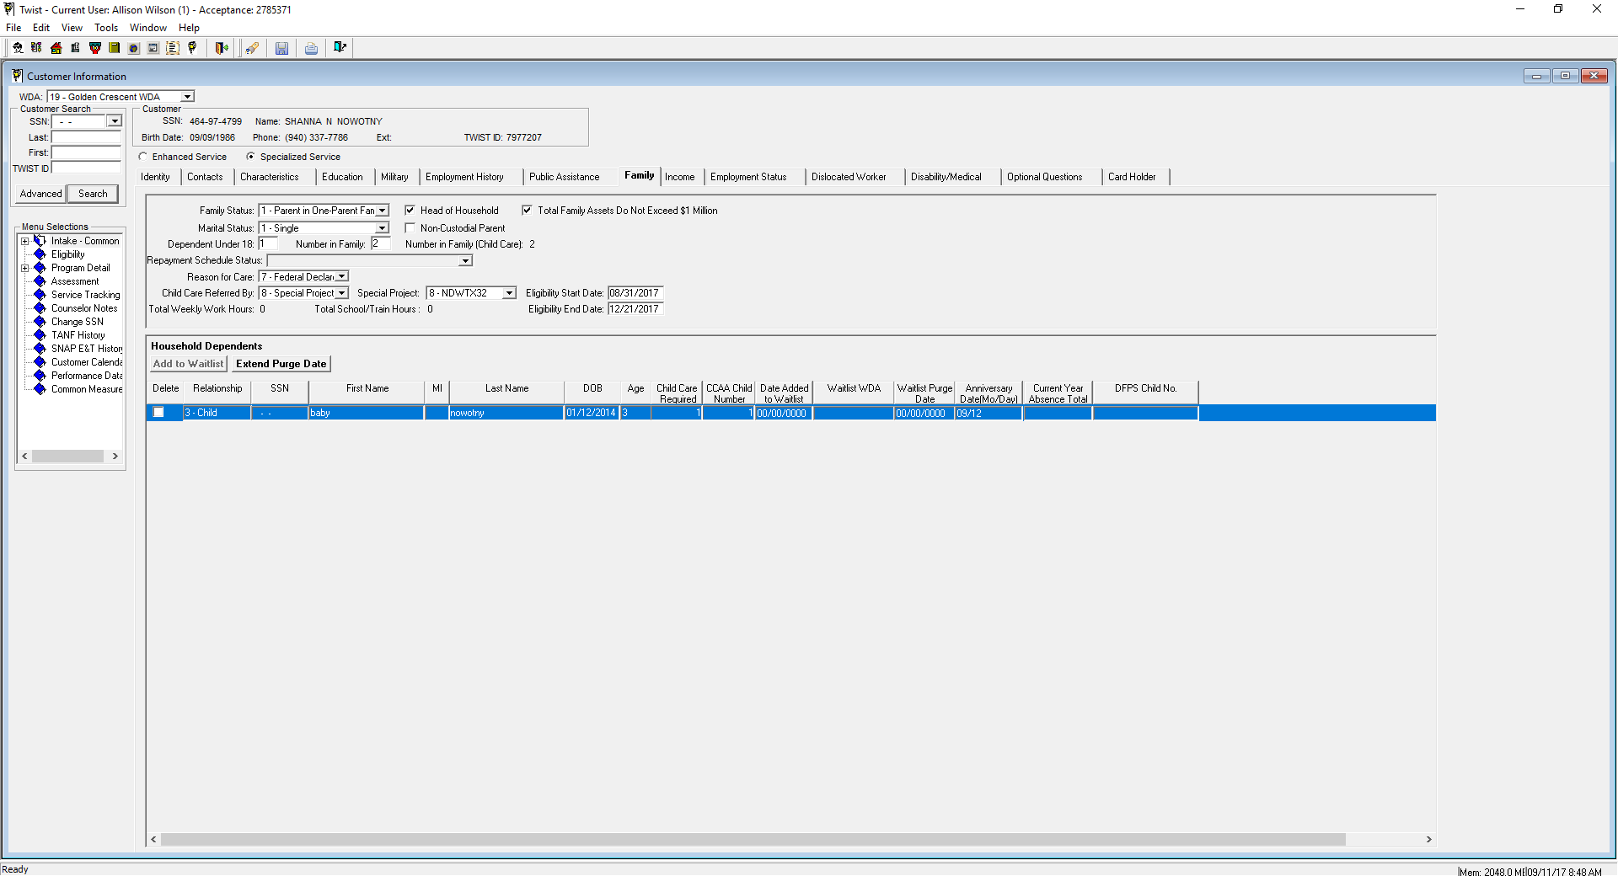

1. In the *Intake-Common* > *Family* tab, select one of the following for **Reason for Care**:

* 5 – Federally Declared Emergency & Employment
* 6 – Federally Declared Emergency & Training/Education
* 7 – Federally Declared Emergency and both Employment & Training/Education

1. For **Child Care Referred By**, select **8 – Special Projects**.
2. For **Special Project**, select **8 – NDWTX32**.

Program Detail

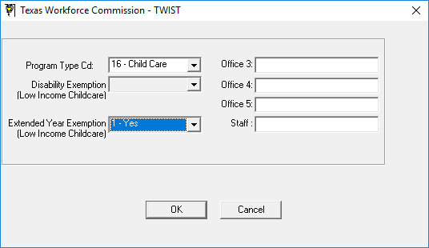

* When creating the Program Detail, select **Program Type**: **16 – Child Care**.
* Select **Extended Year Exemption**: **1 – Yes**.

**Child Care – Child Care Development Fund**

## **Continued Financial Aid for Currently Enrolled Families**

For enrolled children affected by Hurricane Harvey:

* If the parent is displaced from work, training, or education activities because of the hurricane, then this is a temporary status change, and financial aid would continue from September 1, 2017 through November 30, 2017 without being subject to termination.
* If the parent is not participating or is not scheduled to participate in work, training, or education activities by December 1, 2017, then the temporary displacement would be considered a permanent loss of job, training, or education activities, and financial aid would be subject to termination pending the three-month job search period from December 1, 2017 through February 28, 2018. Financial aid would continue through the remainder of the 12-month eligibility period if the parent resumes work, training, or education activities during the job search period.

**Note:** Workforce Solutions may extend an interruption period for longer than 90 days for customers who are unable meet activity requirements by the end of the interruption period because of the hurricane. Extensions to the interruption period may be in increments of 30 days and are based on an individual’s circumstances. In no case will an extension of the interruption period be longer than 60 days.

## **Temporary Extension of the Recertification Period**

* The Financial Aid Support Office may extend the eligibility period for up to five additional months, not to exceed February 28, 2018, for families affected by the hurricane whose eligibility redetermination is scheduled to occur between September 1, 2017, and January 31, 2018.

## **Absences**

* The Financial Aid Support Office must exclude absences that are due to the hurricane from a child’s absence count for *the month of September 2017*.

## **Payments to Child Care Providers**

* If Workforce Solutions continues financial aid for a child enrolled at a provider facility during September 2017, we will reimburse the provider on that authorization and enrollment, *unless the parent requests that care be suspended or that the child be transferred to a new provider or workforce area.*
* However, effective October 1, 2017, for providers that have either temporarily or permanently discontinued operations or have voluntarily removed children due to a reduction in the facilities operating capacity as confirmed and documented by Texas Health and Human Services Commission Child Care Licensing, Workforce Solutions will end authorizations for care at that facility and work with the families to find placement with another eligible provider.   
    
  If an acceptable placement cannot be found, then the Financial Aid Support Office will suspend financial aid.

**Outreach and Participation Tracking**

1. **SNAP E&T and TANF Choices- Work Requirements for Impacted Individuals:**

For both SNAP E&T and TANF Choices, grant good cause beginning Friday August 25th through the end of September, following the existing procedures for granting good cause.

**Beginning October 1st, evaluate customers on a case by case basis to determine if reason for good cause still applies.**

Workforce Solutions will continue to provide transportation and other support service assistance to customers who need this type of assistance to look for employment or to maintain their current employment following our existing requirements for documentation.

1. **Outreach**

SNAP and TANF and RRES

* Outreach week of September 11
* Do not penalize customers for not showing for orientation in September
* **Beginning October 1st, resume normal penalty process for customers who do not show for orientation. Accept reasons for not attending an orientation if related to Hurricane Harvey.**

1. **Participation Tracking**

We continue to collect and record participation hours if the customers submit them.

* Give Good Cause for August and September. (TANF Choices and SNAP E&T)
* Do not penalize anyone who did not meet participation requirements in August or September. (TANF Choices and SNAP E&T)
* Rescind penalty for any customer we already penalized for not meeting participation requirements in August.

1. **Beginning October 1st, resume normal expectations for customers to report participation hours. On a case by case basis, assess continued impact from Hurricane Harvey on customer’s ability to meet participation requirements.**